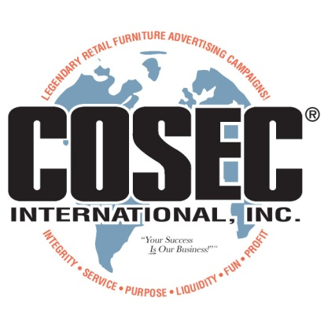
THIS AGREEMENT IS BEING MADE WITH:

Cosec® International, Inc.
3803 South 79th East Avenue ● Tulsa ● OK ● 74145-3218
Phone: 800-227-6152 FAX: 918-622-8189
Email: cosecint @ gmail.com

"PLEASE SEND US THE FOLLOWING ADPAC! produced by Cosec® International, Inc." :

ADPAC! Title:

Desired Date of Your Sale: until

THE AGREEMENT, DATED: (Today’s Date)

"We understand that this is not a purchase of materials and that all the materials ordered are the copyright property of Cosec® International, Inc. We understand that this agreement is made in Tulsa County, Tulsa, Oklahoma, United States of America. We understand we are paying for the right to utilize the Cosec® ADPAC! only in the market(s) as indicated and only on the date(s) indicated above."

"We further understand that we are entitled to the exclusive rights to the newspaper ad(s) and air media voices used in this ADPAC! in our particular media, if we reorder this or another ADPAC! from Cosec® within fifteen (15) days of the ending date of the promotion conducted by this order. We understand that Cosec® International, Inc. requires minimum participation of three (3) promotions each twelve (12) calendar months with any retailer who wished to maintain this exclusive agreement."

"We understand that a repeat fee is required for use of any of this material beyond the sale date(s) scheduled. Repeat usage of this material must be cleared through Cosec® thirty (30) days in advance."

"We agree not to permit removal or deletion of any copyright notices printed on this material."

"We understand that Cosec® material is provided on a “per store” basis only and that a separate fee, order form, and agreement must be executed for each store using any of this copyright material." (Multiple stores, please call for a quote. Multiple use discounts are available.)

"We understand that Cosec® reserves the right to contact us within five (5) days of the receipt of this order regarding alternate dates for this sale should conflicts occur with a previously scheduled event."

"We understand that Cosec® International, Inc. permits electronic orders of ADPAC!s and other materials from established clients and that this order form and agreement is applicable to not only this particular order but also any future orders honored by Cosec® by any electronic means."

"We agree to pay this order and any future orders honored by Cosec® within ten (10) days of said order or by the terms extended by invoice as agreed."

Phone Number: FAX Number:

E-mail Address: Store Name:

Signature: Name &Title:

WHAT IS YOU BIGGEST VOLUME TO DATE FOR THIS PERIOD OF TIME? $

WHAT IS YOUR TARGET VOLUME FOR THIS ADPAC! FROM COSEC® ? $

Form signed? FAX to 918-622-8189. Thank you & remember…Your Success IS Our Business!

